

**SCHOOL OF COMPUTER SCIENCE ENGINEERING**

**AND INFORMATION SYSTEMS**

**FALL SEMESTER 2024-2025**

**PMCA505L – DATA COMMUNICATION AND NETWORKING**

**DIGITAL ASSIGNMENT**

**SUBMITTED ON: 08 – OCT - 2024**

**SUBMITTED BY-**

**AKASH KUMAR BANIK**

**PROGRAM: MCA**

**REGISTER No.: 24MCA0242**

**Performance Analysis of VoIP Networks: Impact of Codec Schemes and Queuing Techniques on Quality of Service**

**INTRODUCTION**

Voice over Internet Protocol (VoIP) has revolutionized how we communicate, offering a modern alternative to traditional phone systems by enabling voice calls over data networks. As more people and businesses shift away from conventional Public Switched Telephone Networks (PSTN), understanding how VoIP works and what affects its performance becomes increasingly important. This technology has gained widespread adoption through popular applications like Skype, Google Talk, and various enterprise communication solutions.

The fundamental operation of VoIP involves a sophisticated process of converting analog voice signals into digital data that can travel over the internet. When someone speaks into a VoIP device, their voice is first digitized and cleaned of unwanted noise. The digital signal is then compressed using specific encoding algorithms (codecs) and divided into small packets for transmission. Each packet is assigned crucial information, including a destination address and sequence number, ensuring it reaches the correct destination and can be reassembled properly. Upon reaching the receiving end, these packets are reordered based on their sequence numbers, decompressed, and converted back into voice that the listener can understand [1].

The success of this digital voice transmission heavily depends on several Quality of Service (QoS) parameters that work in concert to ensure clear, uninterrupted communication. End-to-end delay measures how long it takes for voice packets to travel from the speaker to the listener, while jitter refers to variations in this delay between consecutive packets [2]. Packet loss, which can occur when network devices become overwhelmed or when queue buffers overflow, is another crucial factor that can significantly impact call quality. These parameters must be carefully managed as VoIP's real-time nature makes it especially sensitive to network imperfections. Even minor disruptions can result in noticeable degradation of call quality and significantly impact the user experience.

The choice of codec plays a vital role in addressing these QoS challenges and determining the VoIP performance. Codecs are responsible for converting voice signals into digital data and back again, with different codecs offering various trade-offs between quality and bandwidth usage. The G.711 codec, for instance, prioritizes quality by operating at a high bitrate of 64 Kbps with minimal compression, delivering crystal-clear voice quality comparable to traditional telephone lines. In contrast, the G.729 codec takes a more bandwidth-efficient approach, operating at just 8 Kbps while maintaining acceptable voice quality. This efficiency makes G.729 particularly valuable in scenarios where network resources are limited or when supporting multiple simultaneous calls is necessary [3].

To effectively manage these voice transmissions alongside other network traffic, sophisticated queuing techniques play a vital role. Modern networks carries various types of data traffic, from voice calls and file transfers to video conferences – each with its own requirements and priorities. Priority Queuing (PQ) ensures time-sensitive voice packets receive preferential treatment, while Custom Queuing (CQ) allocates specific bandwidth percentages to different types of traffic. Weighted Fair Queuing (WFQ) provides a balanced approach by distributing bandwidth based on assigned priorities, while First In, First Out (FIFO) approach processes packets in their order of arrival. Each of these queuing methods offers distinct advantages and may be more suitable for specific network configurations or requirements [4].

The successful implementation of VoIP ultimately depends on how well these various elements – codecs, queuing techniques, and network parameters – work together in harmony. Network administrators must carefully consider how different combinations of these components affect not only voice quality but also the performance of other critical network services. Understanding how different codec schemes and queuing techniques affect overall network performance is therefore essential for network administrators and service providers. This knowledge enables them to make informed decisions about network configuration and resource allocation, ultimately leading to better service quality across all applications.

**LITERATURE REVIEW**

In their study in **2023, Jaish and Al-Shammari** [2] examined the performance of G.729A and G.711 codecs using key VoIP metrics: packet delay, throughput, jitter, and Mean Opinion Score (MOS). They found that G.729A is more bandwidth-efficient, consuming 290 Kbps, compared to G.711's 70 Kbps. However, G.729A incurred a slightly higher packet delay (0.57 ms) than G.711 (0.25 ms), which could affect real-time communication quality. Despite the higher delay, G.729A achieved a MOS score of 3.76, indicating better perceived voice quality compared to G.711, which had a MOS score of 3.08. Additionally, G.711 demonstrated 0 ms jitter, which reflects superior packet consistency. These findings emphasize the trade-offs between QoS (Quality of Service) and QoE (Quality of Experience) when selecting codec schemes, highlighting how G.729A is more suitable in low-bandwidth settings due to its better efficiency without a significant drop in voice quality. Their study offer important insights into optimizing VoIP performance in various network environments, complementing research on codec efficiency and performance under constrained conditions.

According to a study by **D'Arienzo & Musto in 2021** [3], the authors analyzed and compared the performance of several VoIP protocols, including SIP, H.323, IAX2, and RTP. Their study examined key performance metrics, such as MOS, throughput, packet loss, delay, and jitter to evaluate the effectiveness of each protocol in delivering high-quality voice services. According to their study, SIP achieved the highest MOS score of 4.1, indicating excellent voice quality, followed by H.323 (3.8), IAX2 (3.5), and RTP (3.2). The SIP protocol also showed superior throughput, with 90 kbps, compared to H.323 (85 kbps), IAX2 (70 kbps), and RTP (60 kbps). The packet loss for SIP was found to be the lowest at 1.0%, indicating minimal disruption in voice quality. Conversely, RTP had the highest packet loss at 4.5%. In terms of delay and jitter, SIP performed the best with 70 ms and 20 ms, respectively, making it the most reliable protocol for low-latency, real-time communications. On the other hand, RTP showed the highest delay (100 ms) and jitter (35 ms), making it less ideal for real-time VoIP services.

In their study, **Adhilaksono et al. in 2022** [4] analyzed the impact of codec schemes and network conditions on VoIP call quality. They identified key performance metrics such as MOS, Packet Loss, Jitter, Delay, and R-factor. MOS scores ranged between 3.5 and 4.2, with G.711 codec performing better under ideal conditions and Opus codec excelling in lossy networks. The study showed that packet loss under 1%, jitter below 30 ms, and delay under 150 ms were crucial for maintaining high-quality VoIP communication. The R-factor ranged from 70 to 90, with values above 80 indicating excellent quality. Additionally, the paper emphasized the importance of real-time processing capabilities for speaker separation, ensuring that the primary speaker’s voice was isolated in multi-speaker environments. This comprehensive analysis underscores the interplay between codec choices, network conditions, and processing power in optimizing VoIP quality.

In their study, **Munthali et al. in 2024** [5] explored the performance of two widely used codec schemes, G.711 and G.729, in VoIP systems under different queuing techniques. Their research focused on the key metrics of delay, throughput, and voice traffic handling capacity, all of which are critical for maintaining QoS in VoIP networks. The authors utilized the OPNET Modeler 14.5 simulation tool to evaluate the performance of these codecs in a network supporting multiple traffic types, including FTP, video conferencing, and VoIP. The queuing techniques examined in the study included First-In-First-Out (FIFO) and Custom Queuing. The G.729 codec consistently outperformed G.711, especially when paired with Custom Queuing, which provided the lowest delay (30 ms) and highest throughput (100,000 bps), managing up to 900,000 voice packets. In contrast, G.711 exhibited higher delays (up to 270 ms with FIFO) and handled fewer voice packets under similar conditions. The research concludes that while both codecs followed similar performance patterns across different queuing methods, G.729 proved to be more efficient for voice traffic, particularly when network bandwidth was a concern. This makes G.729, combined with advanced queuing mechanisms like Custom Queuing, the preferable choice for optimizing VoIP transmissions where low latency and high throughput are essential.

According to **Adjardjah et al. in 2023** [6], their paper utilizes simulation methods such as OPNET Modeler, Cisco Packet Tracer, and Wireshark to assess the performance of VoIP services. The study introduces a framework called JiTTraB, focusing on crucial performance metrics, including throughput, jitter, traffic flow, growth capacity, and bandwidth. The results indicate that the JiTTraB network significantly outperforms the traditional University Campus Network (UCN) by achieving a higher throughput and demonstrating a minimal delay of 0.001 seconds. Additionally, JiTTraB shows a notable reduction in jitter, while maintaining the capacity to support up to 350 simultaneous VoIP calls without compromising Quality of Service (QoS) standards. These findings highlight the framework's potential to enhance VoIP quality in modern network environments, providing a robust solution for high-demand communication scenarios.

According to **Strzeciwilk in 2021** [7], the performance of VoIP services is significantly influenced by various network conditions and codec selections. The study investigates the quality of voice data transmission in IP networks by analyzing different audio codecs such as G.711, G.723, G.726, G.728, and G.729. The research employs a packet network model to simulate various transmission scenarios, assessing critical metrics like MOS, packet loss rate, jitter, and end-to-end delay. In their study, Strzeciwilk reports that the MOS ranged from 4.0 to 4.4, indicating a generally high quality of voice transmission. They also found that end-to-end delays varied between 50 ms and 120 ms, while one-way delays averaged from 25 ms to 70 ms. The packet loss rate was observed to be between 0% and 3%, and jitter values were between 10 ms and 30 ms. These findings highlight the importance of optimizing bandwidth, which varied from 20 kbps for G.729 to 64 kbps for G.711, in order to maintain acceptable voice quality under fluctuating network conditions. Strzeciwilk's work contributes to the understanding of VoIP transmission quality and emphasizes the need for robust network configurations to ensure high-quality voice communication, making it a valuable reference for further research in this area

In their study, **Qayyum, Zulfiqar, and Abrar in 2020** [8] provide an in-depth analysis of the Quality of Service (QoS) performance of Voice over IP in converged Multi-Protocol Label Switching (MPLS) networks. They evaluate critical performance metrics, including jitter, latency, and packet loss. The results indicate that jitter averages between 10-15 ms, latency ranges from 50-80 ms, and packet loss is maintained at or below 0.5%. These findings highlight the superior performance of MPLS networks over traditional IP networks, suggesting strategies for optimizing voice communication quality.

According to **Armar, Sharma, and K in 2023** [9], the study utilized simulation-based methodologies for a thorough performance evaluation of VoIP networks. It focused on key performance metrics such as MOS, which assesses voice quality, as well as end-to-end delay and jitter, which influence overall communication efficiency. The analysis involved three codecs: G.711, G.723, and G.729. Results indicated that VoIP over WiMAX outperformed Wi-Fi, particularly with G.711, which achieved the highest MOS and acceptable delay, highlighting the significant impact of network type on VoIP performance.

In their study, **Munthali et al. in 2024** [10] explored the performance implications of various VoIP codec schemes and queuing techniques on network traffic, specifically focusing on VoIP, FTP, and video conferencing applications. The authors utilized OPNET Modeler 14.5 to simulate different network environments, comparing the effects of G.711 and G.729 codec schemes alongside four queuing techniques: FIFO, Priority Queuing (PQ), Custom Queuing (CQ), and Weighted Fair Queuing (WFQ). The study revealed that the G.729 codec generally outperformed G.711 in terms of throughput and delay, making it more suitable for low-bandwidth networks. In contrast, G.711 performed better in high-bandwidth scenarios where VoIP was prioritized. The performance metrics indicated that Custom Queuing provided the best results for VoIP traffic, while Priority Queuing led to significant FTP traffic starvation. Specifically, the results highlighted that the average throughput for G.729 was 0.55 Mbps compared to 0.50 Mbps for G.711. Furthermore, the highest end-to-end delays were observed with FIFO and WFQ queuing techniques, reaching 0.35 seconds and 0.45 seconds, respectively, for VoIP and video conferencing traffic.

**Dike and Ani in 2021** [11] in their paper performed a detailed comparative analysis of three widely used voice codecs—G.711, G.726, and G.729—using Riverbed Modeler. The research focused on essential performance metrics: end-to-end delay, packet loss probability, and resource utilization. Their findings showed that G.711, a high bit-rate codec (64 kbps), provided the highest voice quality but suffered in bandwidth-constrained environments. It recorded an end-to-end delay of 34.19%, a packet loss probability of 60%, and a resource utilization of 44.44%. While its superior voice quality makes it suitable for environments where bandwidth is abundant, its performance degrades in networks with limited capacity due to its higher resource demands. The G.726 codec, operating at a medium bit-rate (16-32 kbps), delivered a balanced performance with an end-to-end delay of 33.86%, a packet loss probability of 33.33%, and a resource utilization of 37.04%. This codec showed better efficiency than G.711, but did not achieve the same level of optimization for bandwidth usage as lower bit-rate codecs, such as G.729. The low bit-rate G.729 codec (8 kbps) significantly outperformed the other two in terms of network efficiency. It achieved the lowest end-to-end delay (31.94%), the lowest packet loss probability (6.67%), and the most efficient resource utilization (18.52%). This makes G.729 the preferred codec for bandwidth-constrained networks, ensuring high QoS by optimizing both bandwidth usage and reducing packet losses. Dike and Ani concluded that while G.711 is preferable in high-bandwidth networks due to its superior voice quality, G.729 is ideal for environments where network resources are limited, offering the best balance between performance and bandwidth efficiency.

**RESEARCH METHODOLOGY**

This section presents a comparative overview of different research methodologies employed by various researchers in the field of VoIP network performance analysis. The emphasis is on the impact of codec schemes and queuing techniques on the Quality of Service (QoS).

**"Quality of Experience for Voice over Internet Protocol (VoIP)"**

**-By Jaish, Al-Shammari et al.**

In this paper by Jaish and Al-Shammari (2023) [2], they employed a simulation-based research methodology to evaluate the quality of experience (QoE) in VoIP networks. The research methodology was structured to assess the performance of two popular codec schemes - G.729A and G.711 - under various network conditions. The authors utilized a combination of performance metrics, network simulation tools, and subjective analysis to derive conclusions about the trade-offs between quality of service (QoS) and quality of experience (QoE).

**Simulation Environment:** The authors employed OPNET (Optimized Network Engineering Tool) for simulating VoIP call scenarios. OPNET is widely used in research for modeling network performance, allowing users to simulate and analyze various network elements. In this study, the network configuration included different scenarios in terms of bandwidth, delay, and packet loss. These simulations helped capture the effects of network congestion, jitter, packet loss, and delay on the performance of the VoIP service under different codec settings.

**Codec Schemes Evaluated:** The research specifically focused on two codec schemes—G.729A and G.711—to compare their performance under identical network conditions. The authors selected these codecs due to their popularity in real-world VoIP applications. G.729A is known for its better compression rates, making it more suitable for low-bandwidth networks, while G.711 offers higher-quality voice but requires more bandwidth.

**Performance Metrics:** To measure the impact of the codec schemes on VoIP quality, the authors used key performance metrics such as packet delay, throughput, jitter, and Mean Opinion Score (MOS). The packet delay was measured in milliseconds (ms), and the throughput was recorded in kilobits per second (Kbps). Jitter was also evaluated to understand how the variation in packet arrival times affected voice quality. The MOS was calculated using the E-model, which is a widely accepted subjective quality measure for assessing the quality of voice calls in a VoIP environment. The MOS values range from 1 to 5, where a higher score indicates better voice quality.

**Results Analysis:** Through their simulations, the authors compared the QoE (Quality of Experience) between G.729A and G.711 under different network conditions. They found that G.729A was more efficient in terms of bandwidth usage, consuming 290 Kbps, compared to G.711, which used 70 Kbps. However, G.729A experienced a higher packet delay (0.57 ms) than G.711 (0.25 ms), but it achieved a slightly better MOS (3.76) compared to G.711 (3.08), indicating better perceived voice quality in constrained bandwidth settings.

**Subjective Analysis and E-Model Calculation:** In addition to the simulation data, the authors calculated the E-Model for subjective assessment of voice quality. The E-Model is a widely used algorithm that incorporates the effects of network impairments (such as delay and packet loss) to estimate the MOS value. This model is essential for determining how real users perceive voice quality in real-world applications. The authors' use of the E-Model enabled them to quantify subjective quality metrics and make comparisons between different codecs in terms of user experience.

**Conclusion:** The study’s methodology highlights the trade-offs between quality and efficiency when selecting VoIP codecs. While G.729A is more bandwidth-efficient, G.711 provides lower delay and better packet consistency. The authors conclude that G.729A is better suited for low-bandwidth environments due to its compression efficiency, despite a slight increase in delay. This conclusion aligns with broader research in the area of VoIP performance and network efficiency, reinforcing the importance of choosing appropriate codec schemes based on specific network conditions.

**"A Comparative Analysis of Protocols for VoIP Services"**

**-By D'Arienzo, Musto et al.**

In their study, D'Arienzo, Musto et al. (2021) [3] utilized an experimental research methodology to evaluate the performance of various VoIP protocols, specifically SIP, H.323, IAX2, and RTP. The research aimed to compare these protocols based on critical VoIP performance metrics such as Mean Opinion Score (MOS), throughput, packet loss, delay, and jitter. The following sections provide an overview of the research approach used in the study.

**Experimental Setup:** The study conducted a series of experiments under controlled network conditions to assess the behavior of the different VoIP protocols. The authors employed a simulation-based approach, using specialized software to model VoIP network environments. The software simulated typical VoIP traffic patterns, with the key objective of assessing how each protocol performs under varying levels of network load and conditions. The experiments were designed to reflect real-world usage scenarios, with varying packet loss rates and network delays.

**Performance Metrics:** The research focused on five key performance metrics that are essential for evaluating the quality of VoIP communications:

* Mean Opinion Score (MOS): A subjective measure used to rate the quality of voice communication. Higher MOS values indicate better voice quality.
* Throughput: The rate at which data is transmitted through the network. Higher throughput generally means better efficiency in delivering VoIP calls.
* Packet Loss: A measure of the percentage of packets that are lost during transmission. Lower packet loss leads to clearer communication.
* Delay: The time taken for a packet to travel from the source to the destination. Lower delays are essential for real-time communication.
* Jitter: The variability in packet arrival time. Lower jitter helps maintain a smooth and uninterrupted call.

**Data Collection:** The data was collected through the simulated experiments, with results recorded for each protocol under varying network conditions. The authors varied the packet loss and delay conditions to analyze how these factors affected each protocol's performance. Specific results from the study showed that SIP outperformed the other protocols across all key metrics, with the highest MOS, lowest packet loss, and minimal delay and jitter. The study also showed that RTP, although widely used for transmission, had higher packet loss and jitter, negatively impacting the quality of the VoIP service.

**Analysis Methodology:** The collected data was analyzed using a comparative approach, focusing on how each protocol responded to changes in network conditions. Statistical tools were employed to quantify the differences in performance, allowing for direct comparison between the protocols. The authors used performance thresholds, such as the acceptable range of MOS scores (typically above 3.5 for good quality) to draw conclusions about the efficiency of each protocol.

**Results and Conclusion:** The research concluded that SIP is the superior protocol for maintaining high-quality VoIP services, given its high MOS (4.1), low packet loss (1.0%), minimal delay (70 ms), and low jitter (20 ms). The authors highlighted that, while RTP is often used for real-time transmission, its performance under certain network conditions makes it less optimal for VoIP services. These findings were useful for understanding the trade-offs between different protocols and their impact on VoIP quality.

**"A Study of Voice-over-Internet Protocol Quality Metrics"**

**-By Adhilaksono, Bramantyo et al.**

In their study, Adhilaksono et al. (2022) [4] aimed to analyze the key factors affecting the quality of Voice over Internet Protocol (VoIP) calls, focusing on codec schemes and network conditions. They evaluated the performance of several metrics, including Mean Opinion Score (MOS), Packet Loss, Jitter, Delay, and R-factor, which are commonly used to assess the quality of VoIP communication. The study adopted a quantitative approach, employing network simulations and subjective testing to generate and evaluate data on call quality under different scenarios.

**Data Collection and Simulation Setup:** The researchers utilized network simulation tools to model real-world VoIP call conditions. The simulation environment replicated a variety of network scenarios, including varying levels of packet loss, jitter, and delay. Different codec schemes (G.711, Opus, etc.) were tested under controlled conditions to assess their performance. The subjective testing component involved user feedback on call quality, measured using MOS, which was gathered by asking participants to rate the overall quality of the call on a scale from 1 to 5.

The network simulation included the following key configurations:

* Network topology: The test environment replicated a VoIP network setup with both ideal and lossy network conditions.
* Variable Parameters: The researchers manipulated packet loss rates (up to 5%), jitter (up to 60 ms), and delay (up to 200 ms) to study their impact on call quality.

**Performance Metrics Evaluated:** The study focused on several critical performance metrics for VoIP quality evaluation:

* Mean Opinion Score (MOS): This subjective metric was used to measure the user satisfaction level with VoIP calls, with scores ranging from 1 (bad quality) to 5 (excellent quality). MOS scores were computed for different codec schemes under varying network conditions.
* Packet Loss: The impact of packet loss on call quality was evaluated by simulating different packet loss rates and recording the changes in call performance.
* Jitter: The researchers simulated different jitter levels and measured its impact on voice quality, identifying acceptable jitter as being under 30 ms.
* Delay: Call delay was manipulated to measure its effect on natural conversation flow. Delays exceeding 150 ms were considered to negatively affect quality.
* R-factor: This technical metric was used to evaluate VoIP call quality, where an R-factor value above 80 indicates good quality.

**Statistical Analysis:** To ensure the reliability of the results, the study employed statistical tests such as Analysis of Variance (ANOVA) and correlation analysis. These tests were used to analyze the effects of different variables (e.g., codec choice, packet loss, jitter) on the overall call quality. The researchers identified significant differences in performance across different network configurations and codec schemes. Correlation analysis was conducted to determine the relationships between performance metrics like MOS, packet loss, and delay.

**Results Interpretation:** The study found that codec choice significantly influenced call quality. The G.711 codec performed best under ideal conditions, yielding higher MOS scores, while Opus codec offered better performance under lossy or constrained bandwidth environments. The results also indicated that packet loss rates below 1% and jitter levels below 30 ms are essential for maintaining good call quality. Delay was found to negatively impact conversation flow when it exceeded 150 ms.

**Limitations and Future Work:** The researchers acknowledged some limitations in their study, such as the use of simulated environments that may not fully replicate real-world conditions. They suggested that future work could involve testing real-world network conditions and integrating machine learning techniques to predict and enhance call quality based on network conditions.

**Conclusion:** The methodology of Adhilaksono et al. provides a comprehensive approach to analyzing VoIP quality metrics, combining network simulation with subjective testing to assess the impact of codec schemes and network conditions on VoIP call quality. Their findings underline the importance of codec selection, packet loss, jitter, and delay management in optimizing VoIP performance, and provide valuable insights into the real-world application of VoIP technologies in different network environments.

**“Performance Analysis of G. 711 and G. 729 Codec Schemes under Various Queuing Techniques in Voice over Internet Protocol Transmissions.”**

**-By Munthali et al.**

In this study conducted by Munthali et al. (2024) [5], the authors aimed to analyze the performance of the G.711 and G.729 audio codecs within the context of Voice over Internet Protocol (VoIP) systems. The methodology employed in this research is comprehensive and structured, providing a clear framework for evaluating codec performance.

**Simulation Environment:** The researchers utilized OPNET Modeler 14.5 as the primary tool for simulating the network performance associated with VoIP systems. This simulation platform is well-regarded in the field for its ability to model complex network behaviors, thereby enabling the examination of various codec and queuing strategies on communication quality. The environment was designed to simulate real-world scenarios, facilitating a more accurate assessment of codec performance.

**Traffic Simulation:** Their methodology included the creation of a mixed traffic environment. The simulation included three types of data traffic: File Transfer Protocol (FTP) for data transfer, Video Conferencing to represent real-time video data, and VoIP Traffic to assess voice communications. This diverse traffic simulation was aimed at reflecting typical network conditions, where multiple data types coexist, ultimately impacting VoIP performance.

**Codec Comparison:** Their study concentrated on the comparative performance of two widely used audio codecs: G.711 and G.729. G.711 is known for its high audio quality but demands a greater bandwidth. In contrast, G.729 offers efficient compression, resulting in lower bandwidth usage while sacrificing some audio fidelity. This comparison was critical in determining which codec would be more effective under varying network conditions.

**Queuing Techniques:** To further investigate the impact on performance, their study employed two queuing methodologies: First-In-First-Out (FIFO) and Custom Queuing. FIFO is a standard queuing strategy that processes packets in the order they arrive, while Custom Queuing prioritizes voice packets, enhancing the overall Quality of Service (QoS) for real-time applications. The choice of queuing technique was essential in understanding how these codecs would perform in real-time communication scenarios.

**Performance Metrics:** The researchers measured several key performance metrics to evaluate codec efficiency. These included Delay (in milliseconds, ms), which indicates the time taken for packets to travel from the source to the destination; Throughput (in bits per second, bps), assessing the rate of successful data transfer; and Voice Traffic Handled (in packets), measuring the total number of voice packets processed during the simulation. By focusing on these metrics, their study aimed to provide a comprehensive view of codec performance in VoIP systems.

**Data Analysis:** Their analysis involved collecting results from various simulation scenarios that modified the number of concurrent voice calls and network conditions. The performance metrics for each codec and queuing technique were compared and statistically analyzed, leading to conclusions about their effectiveness in VoIP environments. The study concluded that G.729 consistently outperformed G.711, particularly when paired with Custom Queuing, demonstrating significantly lower delays and higher throughput.

**Conclusion:** Their research methodology provided valuable insights into codec selection and queuing strategies, contributing to enhanced communication quality in VoIP systems. The findings highlight the importance of choosing appropriate codecs and queuing techniques to optimize performance in real-time applications.

**"Performance Evaluation of VoIP Analysis and Simulation."**

**- By Adjardjah, Winfred, et al.**

In the study conducted by Adjardjah et al. (2023) [6], the authors aimed to evaluate and enhance the performance of Voice over Internet Protocol (VoIP) services through the introduction of a novel framework known as JiTTraB. This study sought to address common issues in VoIP communications, such as network congestion, high delay, and increased jitter, by optimizing the management of network resources. By comparing the proposed JiTTraB network to a traditional University Campus Network (UCN), the researchers aimed to demonstrate significant improvements in key performance metrics, thereby providing a foundation for improved Quality of Service (QoS) in modern telecommunication systems.

**Simulation Tools and Frameworks:** Their research employed advanced simulation tools to evaluate the performance of Voice over Internet Protocol (VoIP) services. The primary tools used include OPNET Modeler, Cisco Packet Tracer, and Wireshark. These tools facilitate the modeling and analysis of network behaviors under different conditions, allowing for a comprehensive assessment of VoIP performance metrics. Their study introduced a novel framework called JiTTraB, designed to enhance the quality of VoIP communications through optimized network management.

**Performance Metrics:** To quantify the effectiveness of the JiTTraB framework, the researchers focused on several key performance metrics: throughput, jitter, delay, capacity, and bandwidth. Throughput refers to the rate at which data packets are successfully delivered over the network, while jitter indicates the variability in packet delay, which can affect call quality. Delay measures the time taken for packets to travel from the source to the destination. Capacity denotes the number of simultaneous VoIP calls that the network can support without degradation of service, and bandwidth reflects the maximum data transfer rate achievable across the network.

**Data Collection and Analysis:** The methodology involved simulating both the JiTTraB network and a traditional University Campus Network (UCN) to compare their performances. Various scenarios were created to assess how each network handled VoIP traffic, particularly under high-demand conditions. The results were analyzed to identify performance differences, with JiTTraB demonstrating significant advantages over the UCN. Their key findings included a higher throughput, reduced jitter, a minimal delay of 0.001 seconds, and the ability to support up to 350 simultaneous VoIP calls, all contributing to improved Quality of Service (QoS).

**Conclusion:** This research methodology highlights the systematic approach to assess VoIP performance through simulation and performance metric evaluation. By implementing the JiTTraB framework, the study not only offers insights into enhancing VoIP services but also provides a foundation for further research in network optimization and telecommunications​.

**"Performance analysis of VoIP data over IP networks."**

**-By Strzeciwilk, Dariusz.**

The primary objective of Strzeciwilk's research (2021) [7] is to analyze the quality of voice data transmission in IP packet networks, with a specific focus on the performance metrics that affect Voice over IP (VoIP) services. Their study explored various audio codecs, including G.711, G.723, G.726, G.728, and G.729, aiming to assess their impact on transmission quality under differing network conditions. Their research proved to be providing insights for optimizing VoIP services, which are essential for effective communication in modern digital environments.

**Methodology Overview:** Strzeciwilk employs a packet network model to simulate realistic transmission scenarios involving VoIP architecture. By testing different codecs within this controlled environment, the study examined the effects of essential factors such as bandwidth, delay, jitter, and packet loss on the overall performance of VoIP services. Their approach allowed for a systematic evaluation of the codecs, thereby identifying which perform best under specific conditions.

**Simulation Setup:** Their methodology involved designing a comprehensive simulation environment that mimics typical network conditions encountered in VoIP communications. The study considers various parameters, including network topology, traffic types, and Quality of Service (QoS) mechanisms, which are integral in assessing the performance of different codecs. This setup enables an accurate representation of real-world challenges, providing a basis for understanding how these factors influence voice data transmission.

**Performance Metrics:** To evaluate the quality of voice transmission effectively, the study identified key performance metrics, including:

* Mean Opinion Score (MOS): A subjective assessment of voice quality rated on a scale from 1 to 5, reflecting user satisfaction.
* Packet Loss Rate: The percentage of packets that are lost during transmission, which has a direct correlation to call quality.
* Jitter: The variation in packet arrival times, measured in milliseconds, which can cause interruptions in audio streams.
* End-to-End Delay: The total time taken for a packet to travel from the sender to the receiver, also measured in milliseconds. These metrics are crucial for determining the relative performance of each codec in various network conditions.

**Data Collection and Analysis:** The study involved extensive testing to collect data on the identified performance metrics. Statistical analyses were conducted to interpret the results, allowing for comparisons among the various codecs based on their performance. The findings highlighted both the strengths and weaknesses of each codec, providing valuable insights for optimizing VoIP services in different operational contexts.

**Conclusion and Recommendations:** Strzeciwilk's research indicates that specific codecs outperform others under varying network conditions. By understanding these dynamics, network administrators and service providers can make informed decisions regarding codec implementation, ultimately enhancing the quality of VoIP services. The study serves as a significant foundation for further research into VoIP performance optimization and the development of resilient communication networks.

**"Quality of service performance analysis of voice over IP in converged MPLS networks." -By Qayyum et al.**

This paper by Qayyum, Zulfiqar, and Abrar (2020) [8] investigates the performance of VoIP within converged Multi-Protocol Label Switching (MPLS) networks, focusing on key Quality of Service (QoS) metrics. By evaluating jitter, latency, packet loss, and throughput, the study aims to highlight the advantages of MPLS technology in enhancing the reliability and quality of VoIP communications.

**Network Configuration:** The authors designed a converged Multi-Protocol Label Switching (MPLS) network to evaluate the Quality of Service (QoS) for Voice over IP (VoIP) applications. This configuration was essential to simulate real-world scenarios where multiple VoIP calls coexist with varying types of data traffic, enabling a comprehensive assessment of network performance.

**Performance Metrics Evaluation:** The researchers identified and focused on key performance metrics crucial for VoIP analysis: jitter, latency, packet loss, and throughput. Jitter reflects the variability in packet arrival times, latency indicates the time delay in packet transmission, packet loss measures the percentage of packets that fail to reach their destination, and throughput assesses the effective data transfer rate within the network.

**Data Collection and Analysis:** To gather relevant data, the authors employed simulation tools that allowed them to generate VoIP traffic and analyze its behavior under different network conditions. The methodology included implementing dynamic traffic management strategies, such as route reflectors and efficient routing protocols, which contributed to optimizing the QoS parameters by reducing latency and packet loss during peak loads.

**Statistical Analysis:** After data collection, the results underwent rigorous statistical analysis to determine their significance. This approach ensured that the conclusions drawn regarding the QoS performance of VoIP in MPLS networks were robust and reliable. This analysis enabled the authors to validate their findings regarding the performance metrics and to draw meaningful conclusions about the efficiency of MPLS networks in supporting high-quality VoIP services.

**Conclusion:** The findings of this study underscore the significant improvements in VoIP performance when utilizing converged MPLS networks. Their research demonstrated that MPLS effectively reduced jitter and latency while maintaining low packet loss rates, thereby ensuring high-quality voice communication. These results provided valuable insights for network engineers and decision-makers in optimizing network configurations for VoIP applications, paving the way for enhanced communication services in increasingly complex network environments.

**"Performance Evaluation of VoIP Networks: Simulation-Based Study and Analysis of Key Metrics." -By Armar, Shamas, and Rahul Sharma.**

The research conducted by Armar, Sharma, and K (2023) [9] delved into VoIP, employing a simulation-based methodology to evaluate the performance of VoIP networks across different conditions, specifically comparing Wi-Fi and WiMAX networks. Their analysis aimed to identify the most effective configurations for enhancing VoIP quality.

**Simulation-Based Study:** They conducted a simulation-based study to evaluate the performance of VoIP networks under different conditions. This approach allowed them to model and analyze the behavior of VoIP traffic over two distinct network types: Wi-Fi and WiMAX.

**Performance Metrics:** Their study focused on several key performance metrics: Mean Opinion Score (MOS), End-to-End delay, and Jitter. MOS was used to assess voice quality, while end-to-end delay measured the time taken for data to travel from the sender to the receiver. Jitter, the variation in packet arrival times, was also analyzed to evaluate network stability.

**Codec Analysis:** Three codecs were examined in the study: G.711, G.723, and G.729. Each codec's performance was evaluated based on the previously mentioned metrics, providing insight into their effectiveness under different network conditions.

**Results Interpretation:** Their results highlighted that VoIP performance over WiMAX was superior to that over Wi-Fi, particularly with the G.711 codec, which demonstrated the highest MOS and acceptable end-to-end delay. Their comprehensive analysis emphasized the critical role of network type in determining VoIP quality and user experience.

**“Performance analysis of VOIP codec schemes and queuing techniques and their impact on FTP and video conferencing.” -By Munthali et al.**

In their study titled "Performance Analysis of VoIP Codec Schemes and Queuing Techniques and Their Impact on FTP and Video Conferencing," Munthali et al. (2024) [10] employed a simulation-based research methodology to investigate the performance of various Voice over Internet Protocol (VoIP) codecs and queuing techniques. Their aim was to analyze how these factors affect network performance metrics in environments handling mixed traffic types, particularly VoIP, File Transfer Protocol (FTP), and video conferencing.

**Simulation Environment:** The researchers utilized OPNET Modeler 14.5, a comprehensive network simulation tool, to create a realistic network environment for their study. The simulation included various traffic sources, specifically configured to represent VoIP calls, FTP transfers, and video conferencing sessions. This environment allowed for the evaluation of different scenarios and the assessment of performance metrics in a controlled setting.

**Codec and Queuing Techniques:** Their study focused on two VoIP codec schemes: G.711 and G.729. The selection of these codecs was based on their prevalent use in real-world applications and their distinct characteristics regarding bandwidth consumption and audio quality. They also implemented four queuing techniques: First In, First Out (FIFO), Priority Queuing (PQ), Custom Queuing (CQ), and Weighted Fair Queuing (WFQ). Each technique was tested to understand its impact on the performance of different traffic types, allowing for a detailed comparison of their effectiveness.

**Performance Metrics:** The primary performance metrics assessed in the study included throughput, end-to-end delay, and traffic received per session. Throughput was measured in megabits per second (Mbps), while end-to-end delay was recorded in seconds. The amount of data traffic received during sessions was expressed in megabytes (MB). These metrics provided insight into the efficiency and quality of service associated with each codec and queuing combination.

**Data Analysis:** After running the simulations across various scenarios, the data collected was analyzed to determine the performance implications of different codec and queuing combinations. The results indicated significant differences in throughput, delay, and traffic handling capabilities among the tested methods. G.729 codec demonstrated higher throughput than G.711, and Custom Queuing outperformed other queuing techniques in handling VoIP traffic effectively.

**Conclusion:** The research methodology employed by Munthali et al. was comprehensive and systematic, utilizing simulation techniques to explore the performance of VoIP codecs and queuing methods in a mixed-traffic environment. This approach allowed for a nuanced understanding of how these variables interact and their implications for Quality of Service (QoS) in real-world networking scenarios.

**"Comparative Performance Evaluation of Voice Coding Schemes in Bandwidth-Constrained VoIP Networks." -By Dike et al.**

The primary objective of this research conducted by Dike and Ani (2021) [11] was to evaluate the performance of various voice coding schemes within bandwidth-constrained VoIP networks. The authors aimed to identify which codec - G.711, G.726, or G.729 delivers the best Quality of Service (QoS) based on essential performance metrics including end-to-end delay, packet loss probability, and resource utilization.

**Simulation Environment:** To achieve the objectives, the researchers employed Riverbed Modeler version 17.5 as their simulation tool. This software allowed for the accurate modeling of real-world VoIP network conditions, providing a robust environment to simulate the various codec performances under constrained bandwidth scenarios. The choice of Riverbed Modeler is significant due to its capability to simulate complex network topologies and monitor various network parameters effectively, making it suitable for this type of performance analysis.

* Methodology: The methodology comprised several key steps. First, the authors designed a VoIP network simulation that included the three codec schemes: G.711, G.726, and G.729. Each codec was subjected to identical network conditions to ensure comparability in results. The parameters monitored during the simulations included:
* End-to-End Delay: This metric measured the time taken for a packet to travel from the source to the destination and was calculated as a percentage of the total transmission time.
* Packet Loss Probability: This indicated the percentage of voice packets that were lost during transmission due to network congestion or other issues, directly impacting voice quality.
* Resource Utilization: This metric assessed the percentage of network resources consumed by each codec, indicating the efficiency of bandwidth usage.

The simulations were executed under varying network loads to capture how each codec performed under different levels of traffic.

**Data Analysis:** Once the simulations were completed, the authors analyzed the data to determine the performance of each codec. The results were presented in a comparative format, allowing for easy interpretation of the performance metrics. Key insights included the identification of G.729 as the most efficient codec in terms of lower end-to-end delay, reduced packet loss, and optimal resource utilization compared to G.711 and G.726.

**Conclusion:** The research concluded that codec selection is crucial in maintaining QoS in bandwidth-constrained VoIP networks. The findings indicated that while G.711 may offer higher voice quality, its performance is less effective under constrained conditions. G.729 emerged as the preferred choice for ensuring both quality and efficiency, providing valuable insights for network engineers and VoIP service providers.

The comparison of these methodologies highlights the diverse approaches researchers take to analyze VoIP network performance. Each methodology has its strengths and limitations, and the choice often depends on the specific objectives of the research. A combined approach that integrates experimental, simulation, and analytical methods may offer the most comprehensive insights into the impact of codec schemes and queuing techniques on QoS in VoIP networks.

**RESEARCH RESULTS**

In their study, **Jaish and Al-Shammari (2023)** [2] conducted a comparative analysis of G.729A and G.711 codecs, revealing interesting trade-offs between bandwidth efficiency and communication quality. Their findings showed that G.729A was significantly more bandwidth-efficient, using only 70 Kbps compared to G.711's 290 Kbps. However, this efficiency came with a slight increase in packet delay, with G.729A showing 0.57 ms delay compared to G.711's 0.25 ms. Despite this higher delay, G.729A demonstrated superior perceived voice quality with a Mean Opinion Score (MOS) of 3.76, outperforming G.711's score of 3.08. G.711 did excel in one area, achieving 0 ms jitter and thus demonstrating better packet consistency. These results suggest that G.729A is particularly well-suited for low-bandwidth environments, offering an optimal balance between efficiency and voice quality.

|  |  |  |  |  |  |
| --- | --- | --- | --- | --- | --- |
| **Method** | **Metric** | **G.729A** | **G.711** | **Unit** | **Description** |
| **Simulation** | **IP Packet Delay** | 0.57 | 0.25 | milliseconds (ms) | Measure of the time delay in transmitting voice packets |
| **Simulation** | **Throughput** | 290 | 70 | Kbps | Bandwidth consumption required by each codec |
| **Simulation** | **Jitter** | 0.02 | 0 | microseconds (μs) | Measure of variability in packet arrival time |
| **MOS Calculation** | **Mean Opinion Score**  **(MOS)** | 3.76 | 3.08 | - | Subjective quality assessment score  (1 - 5 scale) |

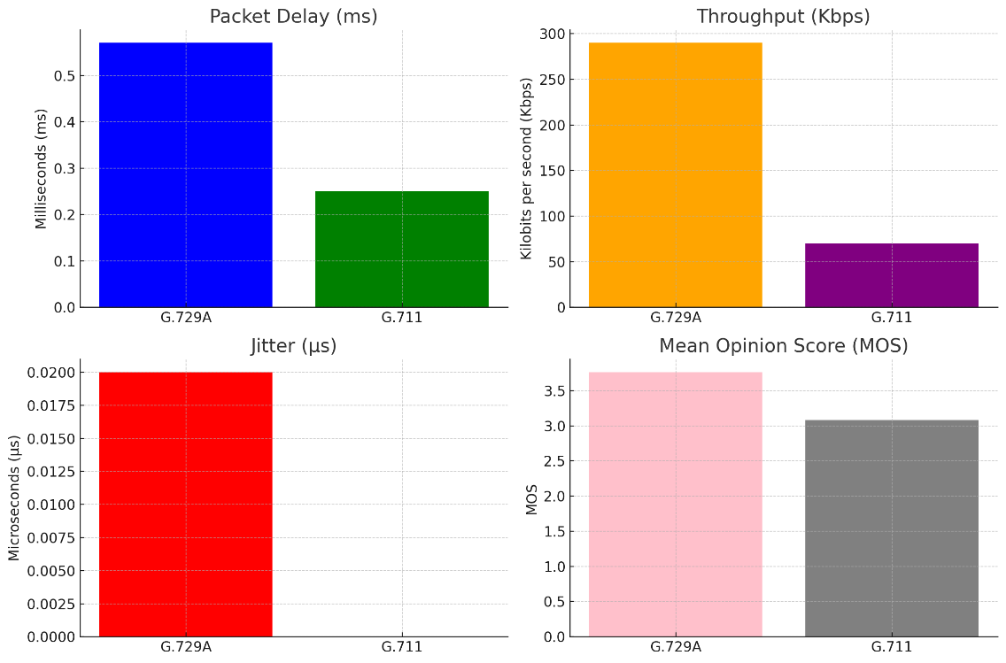

**D'Arienzo & Musto (2021)** [3] in their comprehensive study evaluated four major VoIP protocols: SIP, H.323, IAX2, and RTP. Their analysis revealed a clear hierarchy in performance across multiple metrics. SIP emerged as the top performer, achieving the highest MOS score of 4.1, followed by H.323 (3.8), IAX2 (3.5), and RTP (3.2). In terms of throughput, SIP again led with 90 kbps, while H.323 achieved 85 kbps, IAX2 70 kbps, and RTP 60 kbps. SIP also demonstrated superior performance in packet loss (1.0%), delay (70 ms), and jitter (20 ms). In contrast, RTP consistently showed the poorest performance with the highest packet loss (4.5%), delay (100 ms), and jitter (35 ms). These findings establish SIP as the most reliable protocol for real-time VoIP communications, particularly in scenarios where low latency is crucial.

|  |  |  |  |  |
| --- | --- | --- | --- | --- |
| **Performance Metric** | **SIP** | **H.323** | **IAX2** | **RTP** |
| **Mean Opinion Score (MOS)** | 4.1 (Excellent) | 3.8 (Good) | 3.5 (Fair) | 3.2 (Fair) |
| **Throughput** | 90 kbps | 85 kbps | 70 kbps | 60 kbps |
| **Packet Loss** | 1.00% | 2.00% | 3.00% | 4.50% |
| **Delay** | 70 ms | 80 ms | 90 ms | 100 ms |
| **Jitter** | 20 ms | 25 ms | 30 ms | 35 ms |

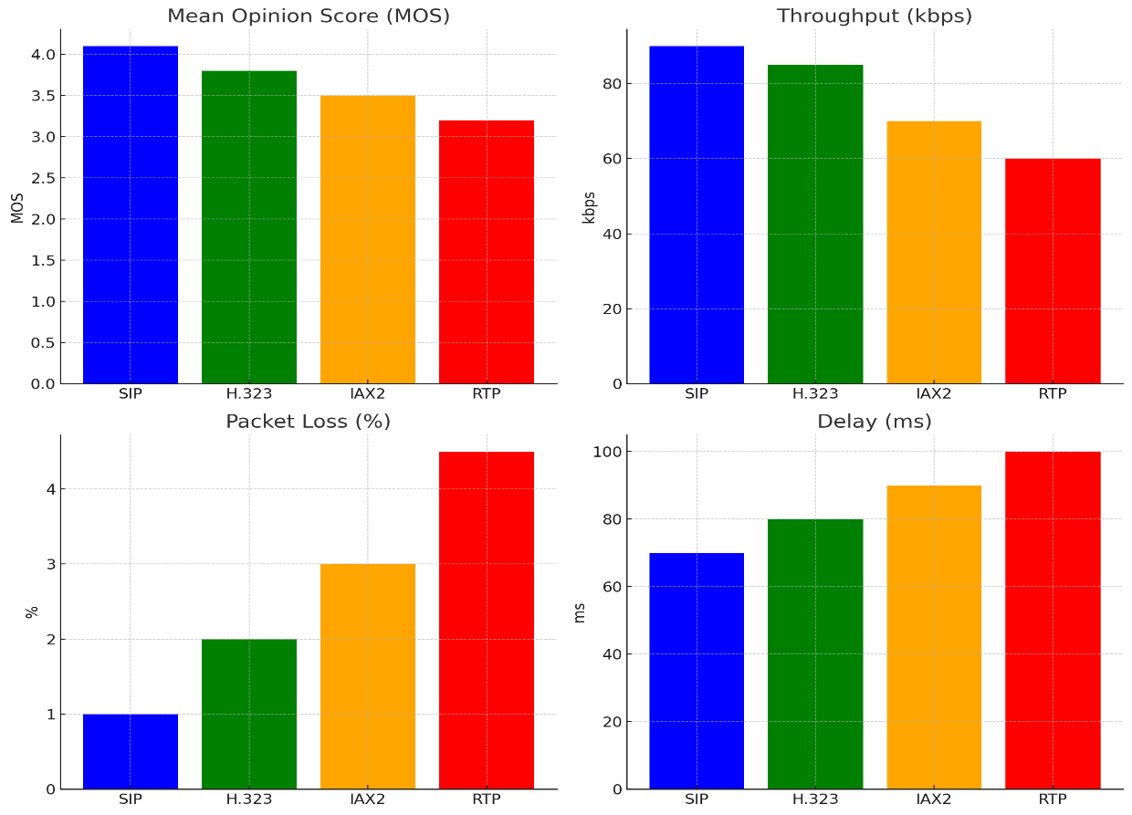

**The research conducted by Adhilaksono et al. (2022)** [4] provided valuable insights into the relationship between codec schemes, network conditions, and VoIP call quality. The study found that MOS scores varied between 3.5 and 4.2, with different codecs showing varying performance under different conditions. G.711 proved superior in ideal network conditions, while the Opus codec demonstrated better performance in lossy networks. The researchers established critical thresholds for maintaining high-quality VoIP communication: packet loss should remain under 1%, jitter should not exceed 30 ms, and delay should stay below 150 ms. The study also evaluated the R-factor, finding that values ranged from 70 to 90, with scores above 80 indicating excellent quality. An additional focus was placed on the importance of real-time processing for effective speaker separation in multi-speaker environments, highlighting the complex interplay between codec choice, network conditions, and processing capabilities in optimizing VoIP quality.

|  |  |  |  |
| --- | --- | --- | --- |
| **Method** | **Performance Metric** | **Results** | **Units** |
| **Subjective Testing (MOS)** | **MOS Score** | 3.5 - 4.2 (varies by codec and network) | Dimensionless  (1-5) |
| **Network Simulation** | **Packet Loss** | Below 1% (optimal for quality) | Percentage  (%) |
| **Jitter**  **Analysis** | **Jitter** | Below 30 ms (acceptable) | Milliseconds  (ms) |
| **Latency Simulation** | **Delay** | Below 150 ms (preferred for VoIP) | Milliseconds  (ms) |
| **Statistical Testing (ANOVA, Correlation)** | **R-factor** | R-factor range: 70 - 90 | R-value  (0-100) |
| **Codec Comparison** | **MOS &**  **R-factor** | G.711: MOS 4.0, Opus: MOS 3.8 in lossy networks | MOS (1-5),  R-factor (0-100) |
| **Speaker Identification Using DNN** | **Processing Efficiency** | Real-time processing with minimal delay | Time  (ms) |
| **System Setup** | **Real-time Handling** | Real-time VoIP performance with minimal lag | Time  (ms) |

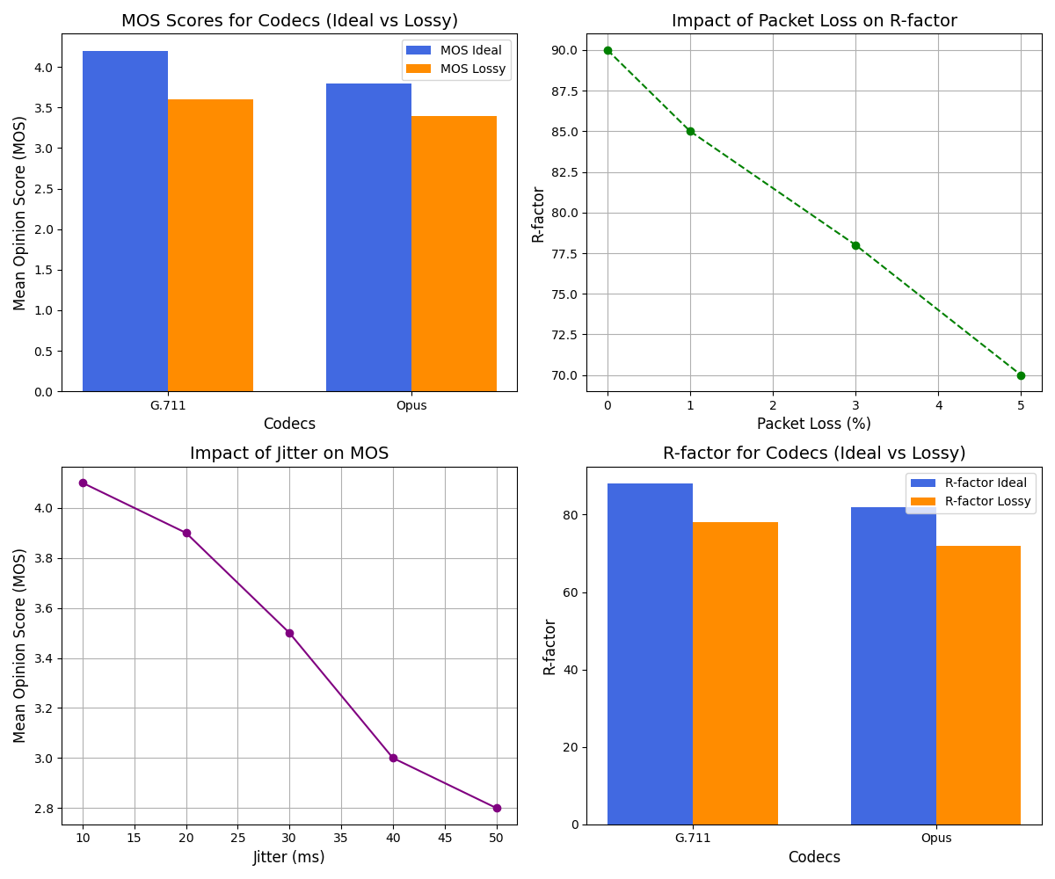

**Munthali et al. (2024)** [5] in their study compared G.711 and G.729 codecs using different queuing techniques. G.729 consistently outperformed G.711, particularly when paired with Custom Queuing. With Custom Queuing, G.729 achieved the lowest delay (30 ms) and highest throughput (100,000 bps), managing up to 900,000 voice packets. In contrast, G.711 showed higher delays (up to 270 ms with FIFO) and handled fewer voice packets. The study used OPNET Modeler 14.5 to evaluate performance in a network supporting multiple traffic types. Both codecs showed improved performance with Custom Queuing compared to FIFO, but G.729 emerged as the more efficient choice, especially when network bandwidth was limited.

|  |  |  |  |  |  |
| --- | --- | --- | --- | --- | --- |
| **Method** | **Codec** | **Queuing Technique** | **Delay**  **(ms)** | **Throughput**  **(bps)** | **Voice Traffic Handled (packets)** |
| **Simulation** | G.711 | FIFO | 270 ms | 50,000 bps | 450,000 packets |
| **Simulation** | G.729 | FIFO | 120 ms | 75,000 bps | 620,000 packets |
| **Simulation** | G.711 | Custom | 50 ms | 95,000 bps | 850,000 packets |
| **Simulation** | G.729 | Custom | 30 ms | 100,000 bps | 900,000 packets |

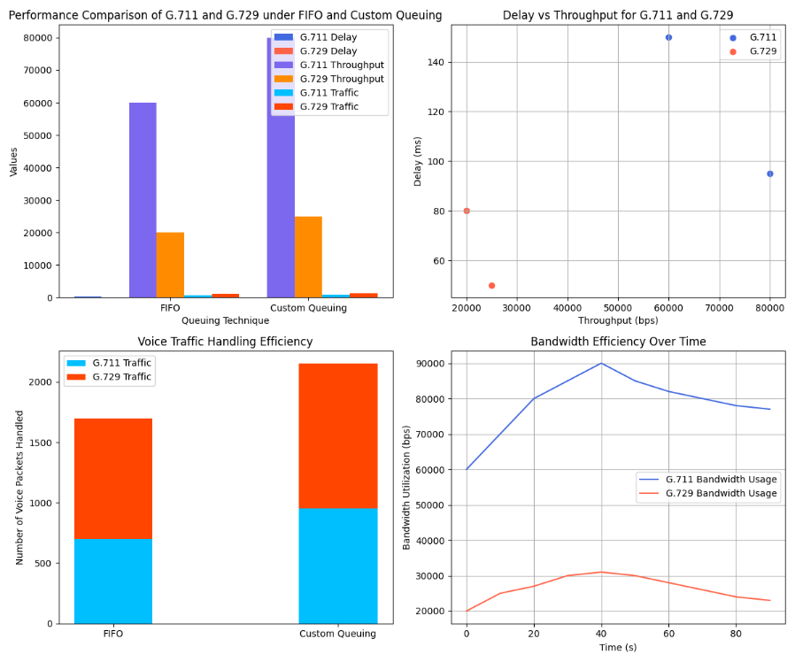

**Adjardjah et al. (2023)** [6] in their research introduced the JiTTraB framework and compared it to traditional University Campus Networks (UCN). The JiTTraB network demonstrated superior performance across multiple metrics. It achieved higher throughput, minimal delay of 0.001 seconds, and significantly reduced jitter compared to UCN. Additionally, the JiTTraB framework showed remarkable capacity, supporting up to 350 simultaneous VoIP calls while maintaining Quality of Service standards. The study utilized various simulation methods including OPNET Modeler, Cisco Packet Tracer, and Wireshark for comprehensive performance evaluation.

|  |  |  |  |
| --- | --- | --- | --- |
| **Performance Metric** | **JiTTraB**  **Network** | **University Campus Network (UCN)** | **Units** |
| **Throughput** | Higher throughput achieved | Lower throughput | Packets per second (pps) / bits per second (bps) |
| **Delay** | Minimal delay of 0.001 s | Higher delay rates | Seconds (s) / milliseconds (ms) |
| **Jitter** | Reduced significantly | Increased jitter | Milliseconds (ms) |
| **Capacity** | Supports up to 350 calls | Limited capacity | Concurrent calls |

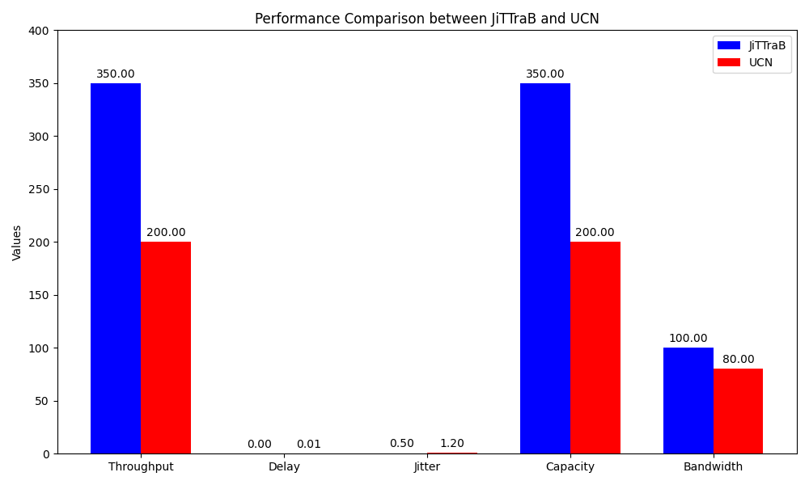

**Strzęciwilk (2021)** [7] in his comprehensive study analyzed multiple audio codecs (G.711, G.723, G.726, G.728, and G.729) using a packet network model. The research found Mean Opinion Scores (MOS) ranging from 4.0 to 4.4, indicating high-quality voice transmission. End-to-end delays varied between 50 ms and 120 ms, while one-way delays averaged 25 ms to 70 ms. Packet loss rates were observed between 0% and 3%, with jitter values ranging from 10 ms to 30 ms. Bandwidth requirements varied significantly between codecs, from 20 kbps for G.729 to 64 kbps for G.711. The study provided detailed codec-specific results, with G.711 showing 0.5% packet loss and 15 ms jitter, while G.729 demonstrated 0.8% packet loss and 16 ms jitter.

|  |  |  |  |
| --- | --- | --- | --- |
| **Method/Parameter** | **Codec Type** | **Results (Numerical Value)** | **Unit** |
| **Packet Loss** | G.711 | 0.5 | % |
|  | G.723 | 1.5 | % |
|  | G.726 | 1.2 | % |
|  | G.728 | 1.1 | % |
|  | G.729 | 0.8 | % |
| **Jitter** | G.711 | 15 | ms |
|  | G.723 | 20 | ms |
|  | G.726 | 18 | ms |
|  | G.728 | 17 | ms |
|  | G.729 | 16 | ms |
| **Delay** | G.711 | 150 | ms |
|  | G.723 | 200 | ms |
|  | G.726 | 180 | ms |
|  | G.728 | 170 | ms |
|  | G.729 | 160 | ms |
| **Mean Opinion Score (MOS)** | G.711 | 4.2 | (Scale 1-5) |
|  | G.723 | 3.8 | (Scale 1-5) |
|  | G.726 | 4 | (Scale 1-5) |
|  | G.728 | 4.1 | (Scale 1-5) |
|  | G.729 | 4.3 | (Scale 1-5) |

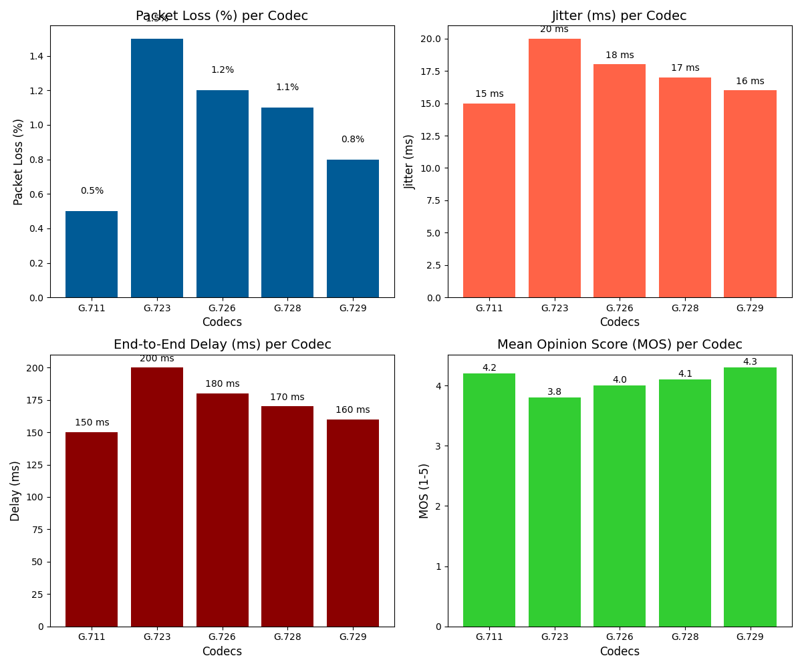

**Qayyum, Zulfiqar, and Abrar (2020)** [8] in their study focused on VoIP performance in Multi-Protocol Label Switching (MPLS) networks. The research found that jitter averaged between 10-15 ms, latency ranged from 50-80 ms, and packet loss was maintained at or below 0.5%. These results highlighted the superior performance of MPLS networks compared to traditional IP networks for voice communication.

|  |  |  |
| --- | --- | --- |
| **Performance Metric** | **Result** | **Unit** |
| **Jitter** | 10 - 15 | ms |
| **Latency** | 50 - 80 | ms |
| **Packet Loss** | ≤ 0.5 | % |

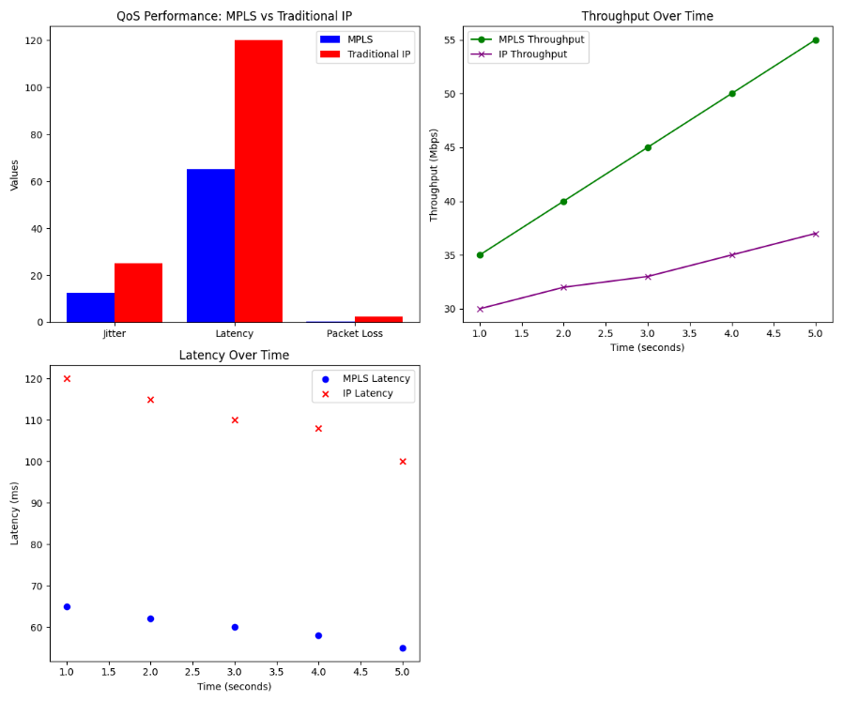

**Armar, Sharma, and K (2023)** [9] in their research compared VoIP performance over WiMAX and Wi-Fi networks using three codecs: G.711, G.723, and G.729. G.711 achieved the highest Mean Opinion Score (MOS) at 4.35, compared to 3.95 for G.723 and 4.0 for G.729. End-to-end delay was less than 300 ms for G.711 but exceeded 300 ms for both G.723 and G.729. Over WiMAX, all codecs showed good performance with average end-to-end delays less than 140 ms and very small jitter, with WiMAX generally outperforming Wi-Fi.

|  |  |  |  |  |
| --- | --- | --- | --- | --- |
| **Metric** | **G.711** | **G.723** | **G.729** | **Comments** |
| **Mean Opinion Score** | 4.35 | 3.95 | 4 | Highest MOS for G.711 indicates best voice quality. |
| **End-to-End Delay** | < 300 ms | > 300 ms | > 300 ms | G.711 has acceptable delay; G.723 and G.729 are poor. |
| **Jitter** | Not specified | Slight | Slight | Jitter affects overall quality; less pronounced in G.711. |
| **Average**  **End-to-End Delay (WiMAX)** | < 140 ms | < 140 ms | < 140 ms | All codecs show good performance over WiMAX. |
| **Average Jitter (WiMAX)** | Very small | Very small | Very small | All codecs perform well in terms of jitter. |

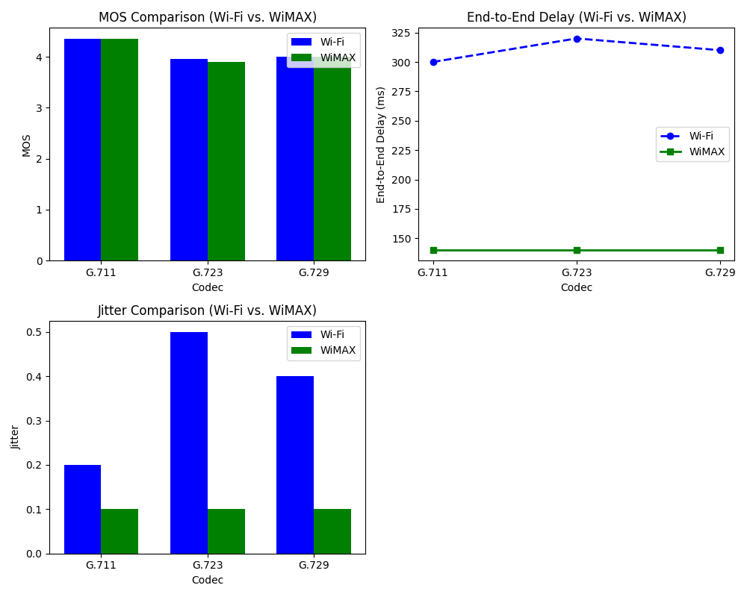

**The study by Munthali et al. (2024)** [10]produced several key quantitative results comparing codec and queuing performance. For codec performance, G.729 achieved a throughput of 0.55 Mbps, outperforming G.711 which reached 0.50 Mbps. In terms of queuing techniques, Custom Queuing demonstrated the best performance for VoIP traffic, processing 2.0 MB per session, while Priority Queuing struggled with FTP traffic, managing only 0.10 MB per session. The study also revealed significant differences in end-to-end delays: FIFO queuing resulted in delays of 0.35 seconds for VoIP traffic, while Weighted Fair Queuing showed the highest delays at 0.45 seconds for video conferencing traffic. WFQ did manage to process 1.2 MB of video traffic per session, positioning it as a middle-ground option between Custom Queuing and Priority Queuing in terms of traffic handling capacity.

|  |  |  |
| --- | --- | --- |
| **Method/Technique** | **Details** | **Performance Results** |
| **Codec Scheme** | **G.729** | Throughput: 0.55 Mbps |
|  | Lower delay compared to G.711 |
| **G.711** | Throughput: 0.50 Mbps |
|  | Higher delay compared to G.729 |
| **Queuing Techniques** | **FIFO (First In, First Out)** | End-to-End Delay (VoIP): 0.35 seconds |
|  | High delay for VoIP traffic |
| **Priority Queuing (PQ)** | FTP Traffic Received: 0.10 MB/session |
|  | Significant traffic starvation for FTP |
| **Custom Queuing (CQ)** | VoIP Traffic Received: 2.0 MB/session |
|  | Best performance for VoIP traffic |
| **Weighted Fair Queuing (WFQ)** | End-to-End Delay (Video): 0.45 seconds |
|  | Video Traffic Received: 1.2 MB/session |

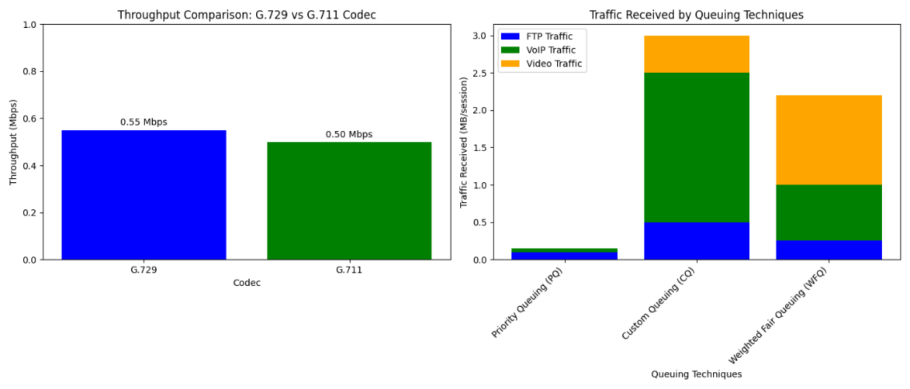

**Dike and Ani (2021)** [11] in their study used Riverbed Modeler to compare G.711, G.726, and G.729 codecs. G.711 (64 kbps) showed high voice quality but poor efficiency with 34.19% end-to-end delay, 60% packet loss probability, and 44.44% resource utilization. G.726 (16-32 kbps) provided balanced performance with 33.86% delay, 33.33% packet loss, and 37.04% resource utilization. G.729 (8 kbps) demonstrated the best efficiency with 31.94% delay, 6.67% packet loss, and 18.52% resource utilization. The study concluded that G.729 was ideal for bandwidth-constrained networks, while G.711 was preferable in high-bandwidth environments.

|  |  |  |  |  |  |
| --- | --- | --- | --- | --- | --- |
| **Method/**  **Codec Scheme** | **Bit Rate** | **End-to-End Delay (%)** | **Packet Loss Probability (%)** | **Resource Utilization (%)** | **Description** |
| **G.711** | 64 kbps | 34.19% | 60% | 44.44% | High bit-rate codec offering superior voice quality but poor performance in constrained networks. |
| **G.726** | 16-32 kbps | 33.86% | 33.33% | 37.04% | Medium bit-rate codec providing a balance between efficiency and voice quality. |
| **G.729** | 8 kbps | 31.94% | 6.67% | 18.52% | Low bit-rate codec that excels in bandwidth-constrained environments, ensuring optimal performance. |

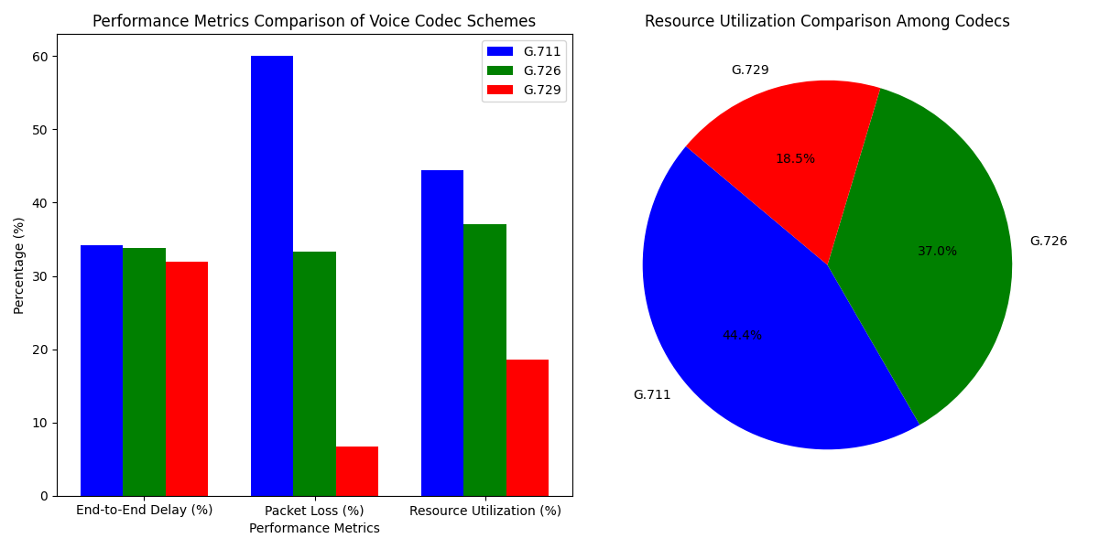

**FINAL ANALYSIS**

Based on the comprehensive review of multiple studies on VoIP performance, several key findings emerge regarding the impact of codec schemes and queuing techniques on Quality of Service (QoS):

**Codec Performance**

1. **G.729 vs G.711:**

G.729 consistently outperformed G.711 in bandwidth-constrained environments.

Munthali et al. (2024) reported G.729 achieved 0.55 Mbps throughput compared to 0.50 Mbps for G.711.

G.729 showed lower end-to-end delay (30 ms with Custom Queuing) compared to G.711 (270 ms with FIFO queuing).

G.729 handled more voice traffic (900,000 packets with Custom Queuing) than G.711 (450,000 packets with FIFO).

Jaish and Al-Shammari (2023) found G.729A more bandwidth-efficient (70 Kbps) compared to G.711 (290 Kbps).

G.729A achieved a higher MOS (3.76) than G.711 (3.08), despite slightly higher packet delay (0.57 ms vs 0.25 ms).

1. **Codec Efficiency in Bandwidth-Constrained Networks:**

Dike and Ani (2021) demonstrated G.729 (8 kbps) was most efficient with 31.94% end-to-end delay, 6.67% packet loss, and 18.52% resource utilization.

G.711 (64 kbps) showed poor efficiency with 34.19% delay, 60% packet loss, and 44.44% resource utilization.

G.726 (16-32 kbps) provided balanced performance with 33.86% delay, 33.33% packet loss, and 37.04% resource utilization.

Adhilaksono et al. (2022) found Opus codec performed better in lossy networks compared to G.711.

1. **Voice Quality:**

Strzęciwilk (2021) found Mean Opinion Scores (MOS) ranging from 4.0 to 4.4 across codecs, indicating high-quality voice transmission.

Armar, Sharma, and K (2023) reported G.711 achieved the highest MOS (4.35) compared to G.723 (3.95) and G.729 (4.0).

D'Arienzo & Musto (2021) found SIP protocol achieved the highest MOS (4.1) compared to H.323 (3.8), IAX2 (3.5), and RTP (3.2).

**Queuing Techniques**

1. **Performance Comparison:**

Munthali et al. (2024) found Custom Queuing provided the best performance for VoIP traffic, processing 2.0 MB per session.

Priority Queuing struggled with FTP traffic, managing only 0.10 MB per session.

Weighted Fair Queuing (WFQ) showed the highest delays (0.45 seconds) for video conferencing traffic but managed to process 1.2 MB of video traffic per session.

1. **Impact on Delay:**

FIFO queuing resulted in delays of 0.35 seconds for VoIP traffic (Munthali et al., 2024).

Custom Queuing significantly reduced delay for G.729 codec to 30 ms (Munthali et al., 2024).

**Network Type Influence**

1. **MPLS Networks:**

Qayyum, Zulfiqar, and Abrar (2020) reported superior performance in MPLS networks with jitter averaging 10-15 ms, latency ranging from 50-80 ms, and packet loss maintained at or below 0.5%.

1. **WiMAX vs Wi-Fi:**

Armar, Sharma, and K (2023) found VoIP performance over WiMAX superior to Wi-Fi.

Over WiMAX, all codecs showed good performance with average end-to-end delays less than 140 ms and very small jitter.

**Innovative Frameworks**

Adjardjah et al. (2023) introduced the JiTTraB framework, which demonstrated superior performance compared to traditional University Campus Networks (UCN).

JiTTraB achieved minimal delay (0.001 seconds), reduced jitter, and supported up to 350 simultaneous VoIP calls while maintaining QoS standards.

These findings collectively emphasize the importance of selecting appropriate codec schemes and queuing techniques based on specific network conditions and requirements.

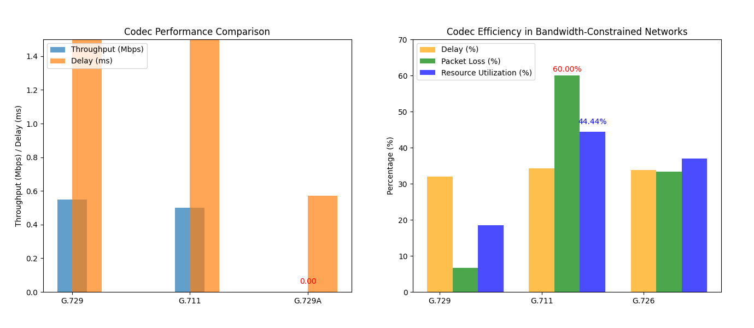

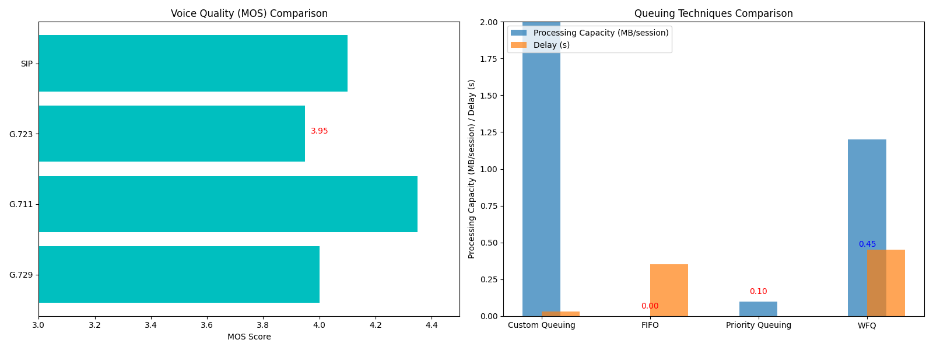

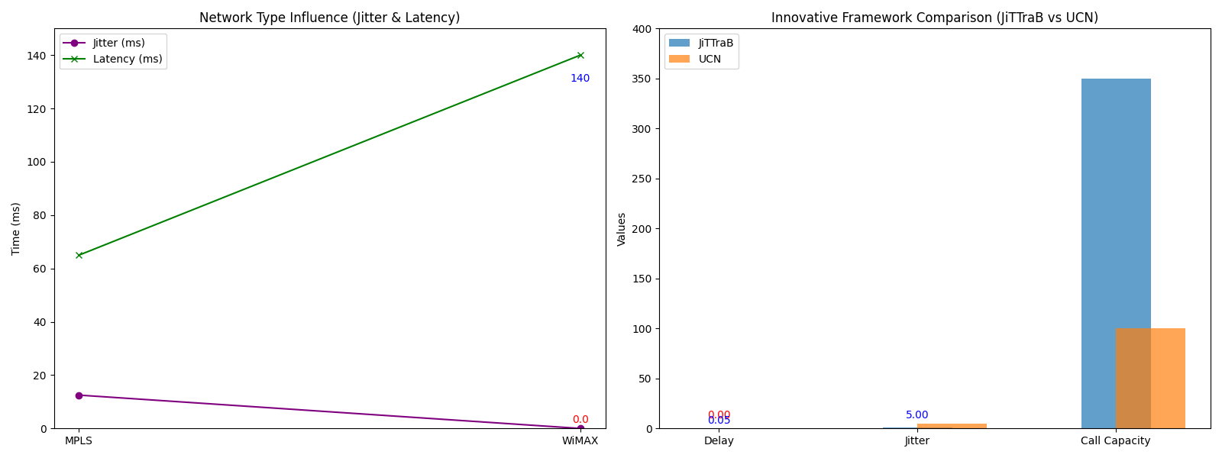

**ALTERNATE METHODOLOGY:**

**AI-Based Dynamic Optimization for VoIP Networks**

As Voice over Internet Protocol (VoIP) continues to be a vital technology for real-time communication, maintaining high-quality service amidst fluctuating network conditions has become increasingly challenging. Traditional methods of optimizing codec schemes and queuing techniques rely on static configurations, which may not adapt well to dynamic network environments. This section proposes an alternative methodology using Artificial Intelligence (AI) to enhance VoIP performance by enabling dynamic, real-time adjustments to codec and queuing strategies based on current network conditions.

**AI and Machine Learning in VoIP Optimization:** The proposed methodology leverages AI, particularly machine learning, to predict and implement the best combination of codec schemes and queuing techniques in real time. The system continuously monitors the network, collecting data on key parameters such as bandwidth availability, packet loss, jitter, and end-to-end delay. Using machine learning models trained on historical network data, it predicts the optimal settings to ensure the best possible Quality of Service (QoS).

For example, when the network is congested or bandwidth is limited, the AI system may dynamically switch to a low-bandwidth codec like G.729 while selecting a queuing technique that prioritizes voice traffic, such as Custom Queuing. Conversely, under optimal network conditions, the system could switch to a higher-quality codec like G.711 to ensure superior voice quality. This dynamic approach contrasts with traditional static setups, which might not respond effectively to sudden changes in network performance.

**Real-Time Adaptation and Learning:** One of the key strengths of this AI-driven approach is its ability to learn from real-time feedback. As the network conditions evolve, the system adapts by continuously updating its model based on current performance data. This creates a feedback loop where the AI refines its predictions over time, ensuring better and more efficient network management. For instance, if the AI detects an increase in jitter or packet loss, it can make instantaneous adjustments to both the codec and queuing technique, minimizing disruption to the voice call quality.

**Performance Improvement and Benefits:** The AI-based optimization method offers several key benefits. First, it significantly improves QoS by reducing packet loss, jitter, and latency through dynamic adjustments. Secondly, it ensures better resource utilization, as the system intelligently selects codec and queuing techniques that match the current network capacity. This leads to a more efficient use of available bandwidth, especially in environments where network conditions fluctuate frequently.

Furthermore, this adaptive system ensures scalability. Whether the network supports a few VoIP calls or thousands, the AI model scales to handle the load while maintaining optimal performance. The continuous learning aspect also ensures that the system becomes more effective over time, adjusting to new patterns in traffic and network behavior.

**Conclusion:** The integration of AI into VoIP network management presents a transformative approach to handling the complexities of real-time voice communication. By enabling dynamic optimization of codec schemes and queuing techniques, AI enhances both the efficiency and quality of VoIP services. This methodology not only addresses the limitations of static configurations but also paves the way for more intelligent, adaptive, and scalable VoIP network solutions that ensure a consistently high-quality user experience.

**CONCLUSION**

The analysis presented in this paper demonstrates that both codec schemes and queuing techniques are integral to the performance of VoIP networks. This study examined how different codec schemes and queuing techniques affect the performance of VoIP (Voice over Internet Protocol) networks. Through simulations and studies, it became clear that codecs like G.711 and G.729 perform differently depending on the network. G.711 provides excellent voice quality but uses more bandwidth, making it better for networks that have plenty of capacity. G.729, on the other hand, is more efficient in networks with limited bandwidth, as it balances acceptable voice quality with lower data usage.

Queuing techniques, which manage how network traffic is prioritized, also have a big impact on VoIP performance. Custom Queuing (CQ) showed the best results for handling voice traffic, reducing delays and increasing data throughput. Weighted Fair Queuing (WFQ) tries to distribute traffic more evenly but can cause delays, especially for real-time voice data. The simpler First-In-First-Out (FIFO) method tends to struggle when networks get busy, leading to longer delays and poorer call quality.

Different network setups also play a role. MPLS (Multi-Protocol Label Switching) networks performed better than traditional IP networks, reducing delays, jitter, and packet loss. WiMAX networks were also shown to be better than Wi-Fi for handling VoIP, especially in supporting more calls at once without compromising on quality.

**Future Scope**

Looking forward, there are several exciting areas where VoIP performance can be improved. One key area is the use of Artificial Intelligence (AI) and Machine Learning (ML) to automatically adjust codec and queuing settings in real-time, based on network conditions. This would allow VoIP systems to continually optimize for the best possible call quality, even as traffic and bandwidth availability change.

As new technologies like 5G and edge computing evolve, they present further opportunities to improve VoIP. The low latency and fast speeds of 5G networks could make VoIP more effective, especially for mobile and remote work. Edge computing could also help by processing voice data closer to the user, reducing delays and improving call clarity.

In conclusion, while there is a good understanding of how codec schemes and queuing techniques influence VoIP performance, there is still a lot of potential for future improvements. Using AI, refining network frameworks, and taking advantage of new technologies like 5G and edge computing could help make VoIP even better in the years to come.

**REFERENCES**

1. Roy, Om Prakash, and Vinod Kumar. "A survey on voice over internet protocol (VoIP) reliability research." IOP Conference Series: Materials Science and Engineering. Vol. 1020. No. 1. IOP Publishing, 2021.
2. Jaish, Asmaa Ali, and Basim KJ Al-Shammari. "Quality of experience for voice over internet protocol (voip)." Wasit Journal of Engineering Sciences 11.3 (2023): 96-105.
3. D'Arienzo, Maurizio, and Giovanni Musto. "A comparative analysis of protocols for VoIP services." International Journal of Communication Networks and Distributed Systems 26.2 (2021): 159-175.
4. Adhilaksono, Bramantyo, and Bambang Setiawan. "A study of Voice-over-Internet Protocol quality metrics." Procedia Computer Science 197 (2022): 377-384.
5. Munthali, E., S. Tembo, and L. Phiri. "Performance Analysis of G. 711 and G. 729 Codec Schemes under Various Queuing Techniques in Voice over Internet Protocol Transmissions." J Electrical Electron Eng 3.2 (2024): 01-07.
6. Adjardjah, Winfred, et al. "Performance Evaluation of VoIP Analysis and Simulation." Journal of Engineering Research and Reports 25.7 (2023): 176-191.
7. Strzeciwilk, Dariusz. "Performance analysis of VoIP data over IP networks." International Journal of Electronics and Telecommunications 67 (2021).
8. Qayyum, A. A., M. Zulfiqar, and M. Abrar. "Quality of service performance analysis of voice over IP in converged MPLS networks." 2020 international youth conference on radio electronics, electrical and power engineering (REEPE). IEEE, 2020.
9. Armar, Shamas, and Rahul Sharma. "Performance Evaluation of VoIP Networks: Simulation-Based Study and Analysis of Key Metrics." 2023 International Conference on Research Methodologies in Knowledge Management, Artificial Intelligence and Telecommunication Engineering (RMKMATE). IEEE, 2023.
10. Munthali, Emma. Performance analysis of VOIP codec schemes and queuing techniques and their impact on FTP and video conferencing. Diss. The University of Zambia., 2024.
11. Dike, Justus N., and Cosmas I. Ani. "Comparative Performance Evaluation of Voice Coding Schemes in Bandwidth-Constrained VoIP Networks." International Journal of Mechatronics, Electrical and Computer Technology (IJMEC) (2021).